1.1

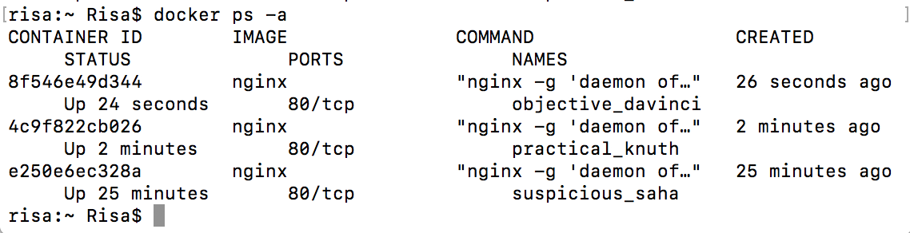Start 3 containers from image that does not automatically exit, such as nginx, detached.

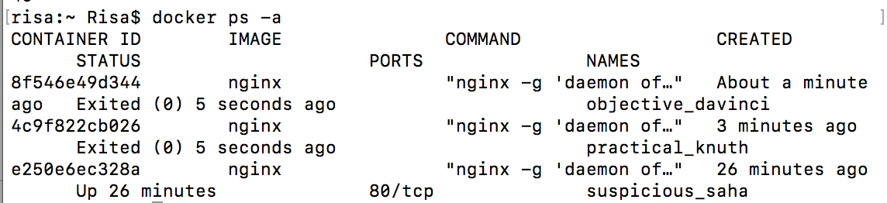Stop 2 of the containers leaving 1 up.

1.2

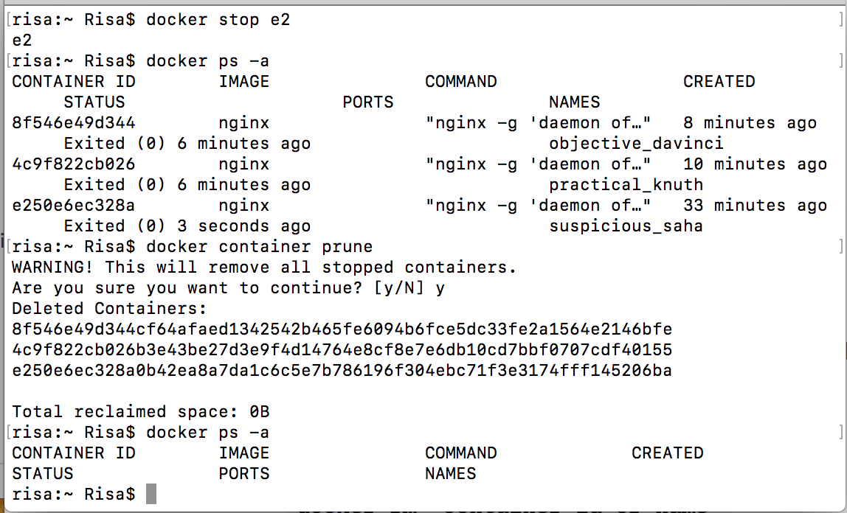We’ve left containers and a image that won’t be used anymore and are taking space, as docker ps -a and docker images will reveal. Clean the docker daemon from all images and containers.

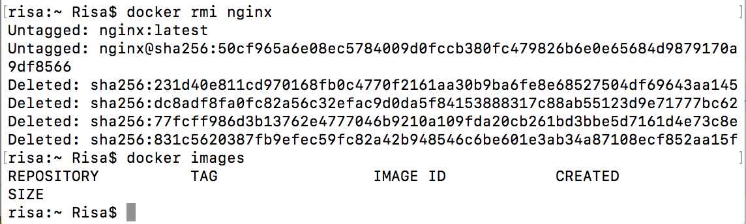

1.3

Submit the secret message and command(s) given to get it as your answer.

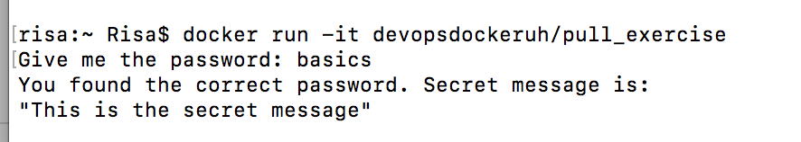

1.4

Submit the secret message and command(s) given as your answer.

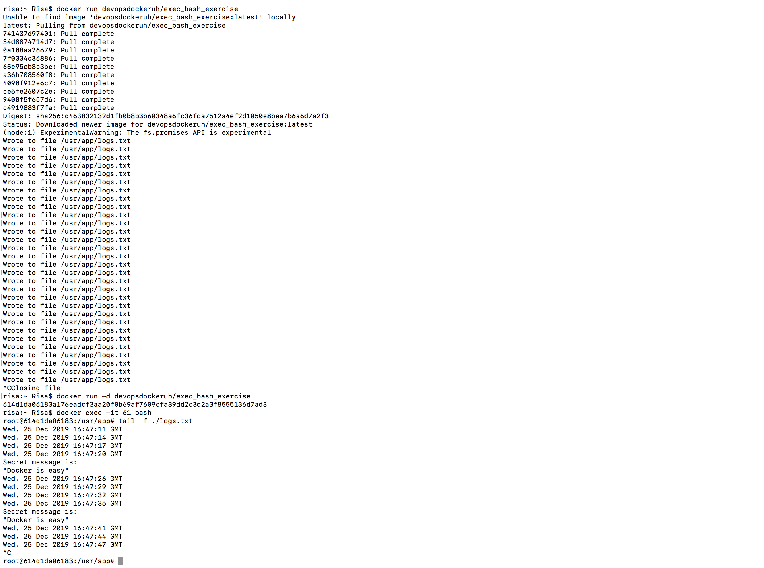

1.5

Start a ubuntu image with the process sh -c 'echo "Input website:"; read website; echo "Searching.."; sleep 1; curl <http://$website>;'

Solution:

docker run -it --name ex_1.5 ubuntu sh -c 'echo "install curl"; apt-get update && apt-get install -y curl; echo "Input website:"; read website; echo "Searching.."; sleep 1; curl http://$website;'

Unable to find image 'ubuntu:latest' locally

latest: Pulling from library/ubuntu

2746a4a261c9: Pull complete

4c1d20cdee96: Pull complete

0d3160e1d0de: Pull complete

c8e37668deea: Pull complete

Digest: sha256:250cc6f3f3ffc5cdaa9d8f4946ac79821aafb4d3afc93928f0de9336eba21aa4

Status: Downloaded newer image for ubuntu:latest

install curl

Get:1 http://archive.ubuntu.com/ubuntu bionic InRelease [242 kB]

Get:2 http://security.ubuntu.com/ubuntu bionic-security InRelease [88.7 kB]

Get:3 http://archive.ubuntu.com/ubuntu bionic-updates InRelease [88.7 kB]

Get:4 http://archive.ubuntu.com/ubuntu bionic-backports InRelease [74.6 kB]

Get:5 http://security.ubuntu.com/ubuntu bionic-security/main amd64 Packages [761 kB]

Get:6 http://archive.ubuntu.com/ubuntu bionic/universe amd64 Packages [11.3 MB]

Get:7 http://security.ubuntu.com/ubuntu bionic-security/multiverse amd64 Packages [6781 B]

Get:8 http://security.ubuntu.com/ubuntu bionic-security/restricted amd64 Packages [19.2 kB]

Get:9 http://security.ubuntu.com/ubuntu bionic-security/universe amd64 Packages [795 kB]

Get:10 http://archive.ubuntu.com/ubuntu bionic/multiverse amd64 Packages [186 kB]

Get:11 http://archive.ubuntu.com/ubuntu bionic/restricted amd64 Packages [13.5 kB]

Get:12 http://archive.ubuntu.com/ubuntu bionic/main amd64 Packages [1344 kB]

Get:13 http://archive.ubuntu.com/ubuntu bionic-updates/restricted amd64 Packages [32.7 kB]

Get:14 http://archive.ubuntu.com/ubuntu bionic-updates/main amd64 Packages [1057 kB]

Get:15 http://archive.ubuntu.com/ubuntu bionic-updates/universe amd64 Packages [1322 kB]

Get:16 http://archive.ubuntu.com/ubuntu bionic-updates/multiverse amd64 Packages [10.5 kB]

Get:17 http://archive.ubuntu.com/ubuntu bionic-backports/universe amd64 Packages [4244 B]

Get:18 http://archive.ubuntu.com/ubuntu bionic-backports/main amd64 Packages [2496 B]

Fetched 17.4 MB in 3s (5979 kB/s)

Reading package lists... Done

Reading package lists... Done

Building dependency tree

Reading state information... Done

The following additional packages will be installed:

  ca-certificates krb5-locales libasn1-8-heimdal libcurl4 libgssapi-krb5-2 libgssapi3-heimdal libhcrypto4-heimdal libheimbase1-heimdal libheimntlm0-heimdal libhx509-5-heimdal libk5crypto3 libkeyutils1 libkrb5-26-heimdal libkrb5-3

  libkrb5support0 libldap-2.4-2 libldap-common libnghttp2-14 libpsl5 libroken18-heimdal librtmp1 libsasl2-2 libsasl2-modules libsasl2-modules-db libsqlite3-0 libssl1.1 libwind0-heimdal openssl publicsuffix

Suggested packages:

  krb5-doc krb5-user libsasl2-modules-gssapi-mit | libsasl2-modules-gssapi-heimdal libsasl2-modules-ldap libsasl2-modules-otp libsasl2-modules-sql

The following NEW packages will be installed:

  ca-certificates curl krb5-locales libasn1-8-heimdal libcurl4 libgssapi-krb5-2 libgssapi3-heimdal libhcrypto4-heimdal libheimbase1-heimdal libheimntlm0-heimdal libhx509-5-heimdal libk5crypto3 libkeyutils1 libkrb5-26-heimdal libkrb5-3

  libkrb5support0 libldap-2.4-2 libldap-common libnghttp2-14 libpsl5 libroken18-heimdal librtmp1 libsasl2-2 libsasl2-modules libsasl2-modules-db libsqlite3-0 libssl1.1 libwind0-heimdal openssl publicsuffix

0 upgraded, 30 newly installed, 0 to remove and 0 not upgraded.

Need to get 4834 kB of archives.

After this operation, 14.8 MB of additional disk space will be used.

…….

Updating certificates in /etc/ssl/certs...

0 added, 0 removed; done.

Running hooks in /etc/ca-certificates/update.d...

done.

Input website:

helsinki.fi

Searching..

<!DOCTYPE HTML PUBLIC "-//IETF//DTD HTML 2.0//EN">

<html><head>

<title>301 Moved Permanently</title>

</head><body>

<h1>Moved Permanently</h1>

<p>The document has moved <a href="http://www.helsinki.fi/">here</a>.</p>

</body></html>

risa:~ Risa$ docker images

REPOSITORY          TAG                 IMAGE ID            CREATED             SIZE   STATUS                          PORTS               NAMES

ubuntu              latest              549b9b86cb8d        6 days ago          64.2MB